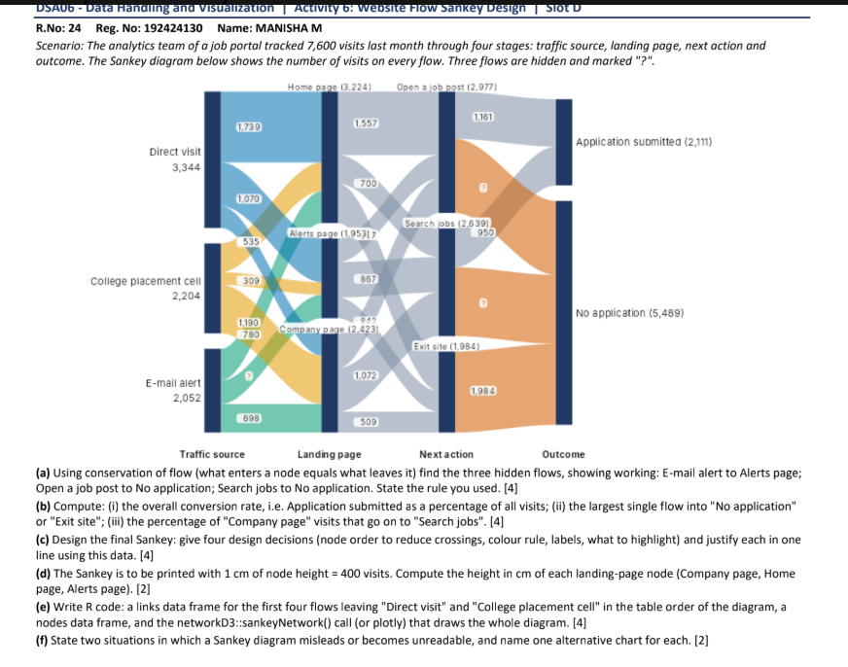

Website Flow Sankey Design
The diagram represents 7,600 visits. Each stage conserves that total: traffic source to landing page, landing page to next action, and next action to outcome. The calculations below use the node and link values shown in the supplied question.

(a) Find the three hidden flows
E-mail alert to Alerts page: Alerts page receives 1,953 visits. Direct visit contributes 1,070 and College placement cell contributes 309. Therefore the missing E-mail alert flow is 1,953 - 1,070 - 309 = 574 visits.
Open a job post to No application: Open a job post has 2,977 visits. Of these, 1,161 lead to Application submitted, so 2,977 - 1,161 = 1,816 visits lead to No application.
Search jobs to No application: Search jobs has 2,639 visits, with 950 leading to Application submitted. Thus 2,639 - 950 = 1,689 visits lead to No application.

(b) Calculate the requested percentages
Overall conversion rate = Application submitted / all visits × 100 = 2,111 / 7,600 × 100 = 27.78% (about 27.8%).
The three incoming flows to No application are 1,816 from Open a job post, 1,689 from Search jobs, and 1,984 from Exit site. The largest is Exit site: 1,984 / 5,489 × 100 = 36.15% (about 36.2%) of all visits with no application.
Company page to Search jobs = 1,072 / 2,423 × 100 = 44.24% (about 44.2%) of Company page visits.

(c) Four design decisions for the final Sankey
Node order. Keep the four stages in the measured journey order: Traffic source, Landing page, Next action, Outcome. Order nodes within each stage by a stable, meaningful sequence and keep that order consistent with the data. This helps readers trace the journey and reduces unnecessary crossings.
Colour rule. Use one consistent colour per traffic source for its outgoing links, with a restrained palette and adequate contrast. Keep node bars neutral/dark and do not assign unrelated colours to the same source in different parts of the diagram.
Labels. Label every node with its name and visit total, format counts with commas, and label links where space permits. Place small link labels on high-contrast backgrounds and avoid overlapping the ribbons.
What to highlight. Emphasize the 2,111 applications and the largest loss, 1,984 exits from Exit site, using a stronger accent or callout. Keep the remaining links muted so the key conversion and drop-off remain visible without hiding the full flow.

(d) Landing-page node heights for printing
At 1 cm per 400 visits, node height = visits / 400. Company page: 2,423 / 400 = 6.0575 cm, or 6.06 cm. Home page: 3,224 / 400 = 8.06 cm. Alerts page: 1,953 / 400 = 4.8825 cm, or 4.88 cm. These are the node heights; spacing between nodes is additional.

(e) R code and diagram output
The data frame below lists the first flows from Direct visit and College placement cell in the same destination order as the diagram: Home page, Alerts page, Company page. The node table records totals for all four stages. The networkD3 call draws the complete diagram.
nodes <- data.frame(name = c(
"Direct visit", "College placement cell", "E-mail alert",
"Home page", "Alerts page", "Company page",
"Open a job post", "Search jobs", "Exit site",
"Application submitted", "No application"
))
links <- data.frame(
source = c(0,0,0, 1,1,1, 2,2,2, 3,3,3, 4,4,4, 5,5,5, 6,6,7,7,8,8),
target = c(3,4,5, 3,4,5, 3,4,5, 6,7,8, 6,7,8, 6,7,8, 9,10,9,10,9,10),
value = c(1739,1070,535, 705,309,1190, 780,574,698,
1557,700,967, 700,867,386, 720,1072,631,
1161,1816,950,1689,0,1984)
)
sankeyNetwork(Links = links, Nodes = nodes, Source = "source",
Target = "target", Value = "value", NodeID = "name",
fontSize = 12, nodeWidth = 24, sinksRight = FALSE)
Check: each stage totals 7,600 visits. The source-to-landing rows are Direct visit (1,739, 1,070, 535) and College placement cell (705, 309, 1,190).
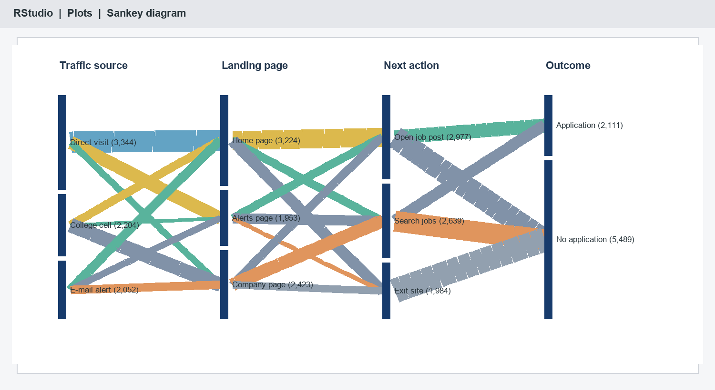
Sankey output preview

(f) When a Sankey can mislead and alternatives
A Sankey can become unreadable when there are many thin links, many stages, or labels that overlap; use a ranked bar chart or a filtered small-multiple Sankey for that case. It can also suggest causation or precise comparisons when flows are incomplete, aggregated, or based on inconsistent visit definitions; use a clearly labeled conversion table or a funnel chart with denominators and stage conversion rates.

